**A**

**MINI PROJECT REPORT**

**ON**

“YOUTUBE VIDEO DOWNLOADER”

**Submitted as partial fulfillment for the award of**

**BACHELORS OF TECHNOLOGY DEGREE**

Session 2022-23

**In**

**Computer Science and Engineering**

## Submitted by:

Sreethu K Binu (2100970100117)

Tarun Shukla (2100970100123)

**Under the supervision of :**

**Ms. Chitrangada Chaubey**



## DEPARTMENT OF COMPUTER SCIENCE AND ENGINEERING

## GALGOTIAS COLLEGE OF ENGINEERING AND TECHNOLGY

GREATER NOIDA



AFFLIATED TO

Dr. A.P.J. ABDUL KALAM TECHNICAL UNIVERSITY

LUCKNOW

i

# CERTIFICATE

This is to certify that the mini-project report entitled “**YOUTUBE VIDEO DOWNLOADER**” submitted by Ms. **SREETHU K BINU (2100970100117)** and Mr. **TARUN SHUKLA (2100970100123)** to Galgotias College of Engineering & Technology, Greater Noida, Utter Pradesh, affiliated to Dr. A.P.J. Abdul Kalam Technical University, Lucknow, Uttar Pradesh in partial fulfillment for the award of Degree of Bachelor of Technology in Computer science & Engineering is a bonafide record of the project work carried out by them under my supervision during the academic year 2022-2023.

**Prof. Chitrangada Chaubey Dr.Vishnu Sharma**

**Dept. of CSE Professor and Head**

**Deptt.of CSE**

ii

# ACKNOWLEDGEMENT

We have taken efforts in this project. However, it would not have been possible without the kind support and help of many individuals and team members. We would like to extend my sincere thanks to all of them.

We are extremely indebted to **Dr. Vishnu Sharma**, HOD, Department of Computer Science and Engineering, GCET and **Prof.Chitrangada Chaubey**, Project Coordinator, Department of Computer Science and Engineering, GCET for their valuable suggestions and constant support throughout my project tenure. We would also like to express our sincere thanks to all faculty and staff members of Department of Computer Science and Engineering, GCET for their support in completing this project on time.

We also express gratitude towards our parents for their kind co-operation and encouragement which helped us in completion of this project. Our thanks and appreciations also go to our friends in developing the project and all the people who have willingly helped us out with their abilities.

SREETHU K BINU 2100970100117

TARUN SHUKLA 2100970100123

iii

**ABSTRACT**

Youtube video downloader enables you to download Youtube videos using the URL of the video that is to be downloaded. The desired video can be downloaded without misleading ads and redirection, within just a few seconds. in this mini project, we have made use of two python libraries - "tkinter" and "pytube". This Youtube video downloader will be useful for downloading videos directly from Youtube by copying and pasting the URL of the video. There will be no need to search for online video downloaders that mostly redirect websites and consist of a number of misleading advertisements. So, a video can be downloaded from Youtube in a few clicks within a very short time.

iv

**TABLE OF CONTENTS**

|  |  |  |
| --- | --- | --- |
| **S. No.** | **CONTENT** | **PAGE NO.** |
|  | **TITLE**  **CERTIFICATE**  **ACKNOWLEDGEMENT**  **ABSTRACT**  **CONTENTS** | **i**  **ii**  **iii**  **iv**  **v** |
| 1. | **INTRODUCTION** | 1 |
| 2. | **PROPOSED WORK AND SYSTEM DESIGN**  2.1. SYSTEM REQUIREMENTS  2.2. SYSTEM DESIGN | 2 |
| 3. | **SOURCE CODE AND ITS EXPLANATION** | 3 |
| 4. | **RESULT AND DEMONSTRATION** | 6 |
| 5. | **CONCLUSION** | 8 |
| 6. | **REFERENCES** | 14 |

v

**INTRODUCTION**

The Youtube downloader project is a python project. Python is used in the Youtube downloader software. The object of this project is to download any type of video in a fast and easy way from youtube in your device.

In this python project, user has to copy the youtube video URL that they want to download and simply paste that URL in the ‘paste link here’ section and click on the download button, it will start downloading the video. When video downloading finishes, it shows a message ‘downloaded’ popup on the window below the download button.

We used the fundamental concepts of python, tkinter, and the pytube package to complete this project. **Tkinter**is a well-known GUI package that is one of the most straightforward methods to create a graphical user interface. **pytube**is a Python library for getting videos from YouTube.

Run the pip installer command on the command line to install the needed modules:

pip install tkinter

pip install pytube

To create a YouTube video downloader project in Python, follow these steps:

* Libraries should be imported.
* Make a display window.
* Make a field for entering the link.
* To begin downloading, create a function.

**PROPOSED WORK AND SYSTEM DESIGN**

**2.1 System Design**

System analysis and design deal with planning the development of information systems through understanding and specifying in detail what a system should do and how the components of the system should be implemented and work together. System analysis and design solve business problems through analyzing the requirements of information systems and designing such systems by applying analysis and design techniques. System analysis and design is the most essential phase in the development of a system since the logical system design arrived at as a result of systems analysis which is in turn converted into physical system design.

**2.2 General System Architecture**

The architecture of applications is usually broken into logical chunks called "tiers", where every tier is assigned a role. A “tier” can also be referred to as a “layer”. There are three layers involved in the application namely Presentation Layer, Business Layer and Data Layer.

**SOURCE CODE**

from tkinter import *

from pytube import YouTube

root = Tk()

root.geometry('450x300')

#root.resizable(0, 0)

root.title("Youtube Video Downloader")

# Title of the program

Label(root, text='Youtube Video Downloader',

font='arial 15 bold').pack()

# Title of the program

link = StringVar() # Variable for save link of video

filename = StringVar()

# Variable for save link of video

Label(root, text='Paste Link Here:', font='arial 13 bold').place(x=160, y=40)

link_enter = Entry(root, width=45, textvariable=link).place(x=50, y=90)

# Input for add the link

def Download(): # Function for download video

Label(root, text='Downloading', font='arial 13').place(x=180, y=210)

url = YouTube(str(link.get()))

video = url.streams.get_highest_resolution()

video.download()

Label(root, text='Downloaded', font='arial 15').place(x=180, y=210)

Button(root, text='Download', font='arial 15 bold',padx=2,command=Download).place(x=180, y=150)

root.mainloop()

**EXPLANATION**

Starting the project by importing the required modules.

In this python project, we import Tkinter and pytube modules.

Creating display window:

* **Tk()** used to initialize tkinter to create display window
* **geometry()** used to set the window’s width and height
* **resizable(0,0)** set the fix size of window
* **title()** used to give the title of window
* **Label()** widget use to display text that users can’t able to modify.
* **root** is the name of the window
* **text** which we display the title of the label
* **font** in which our text is written
* **pack** organized widget in block

Creating field to enter link:

* **link** is a string type variable that stores the youtube video link that the user enters.
* **Entry()** widget is used when we want to create an input text field.
* **width** sets the width of entry widget
* **textvariable** used to retrieve the value of current text variable to the entry widget
* **place()** use to place the widget at a specific position

Creating function to start downloading:

Url variable gets the youtube link from the link variable by **get()** function and then **str()** will convert the link in string datatype.

The video is download in the first present stream of that video by **stream.first()** method.

**Button()** widget used to display button on the window.

* **text** which we display on the label
* **font** in which the text is written
* **bg** sets the background color
* **command** is used to call the function

**root.mainloop()** is a method that executes when we want to run the program.

**RESULT AND DEMONSTRATION**

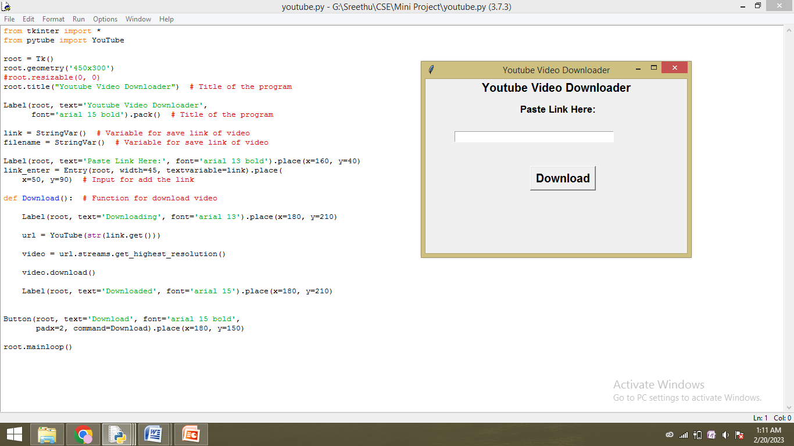

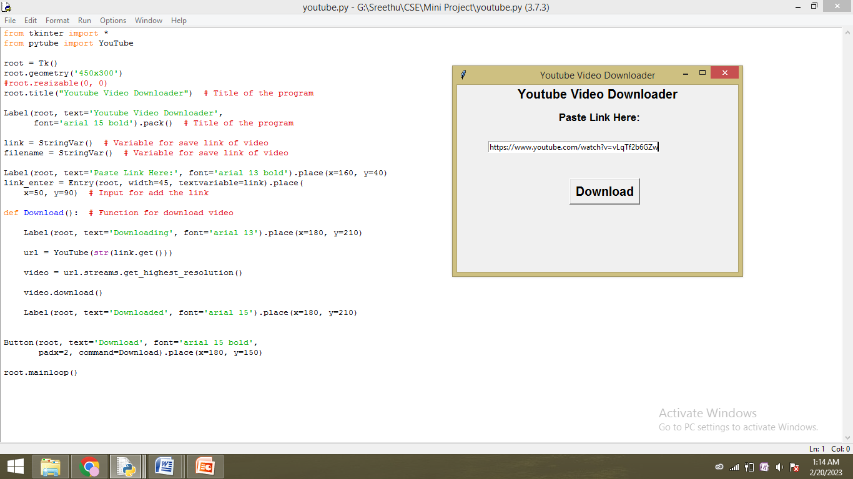

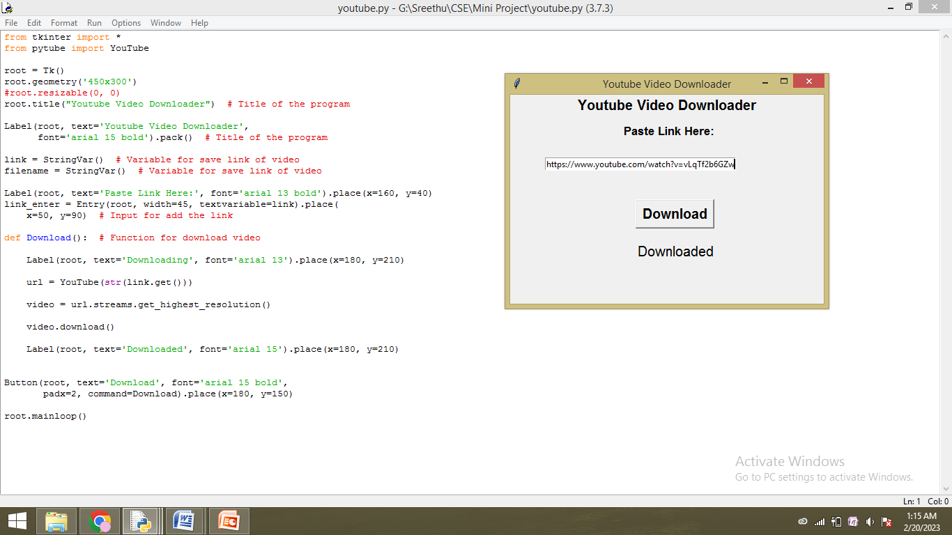

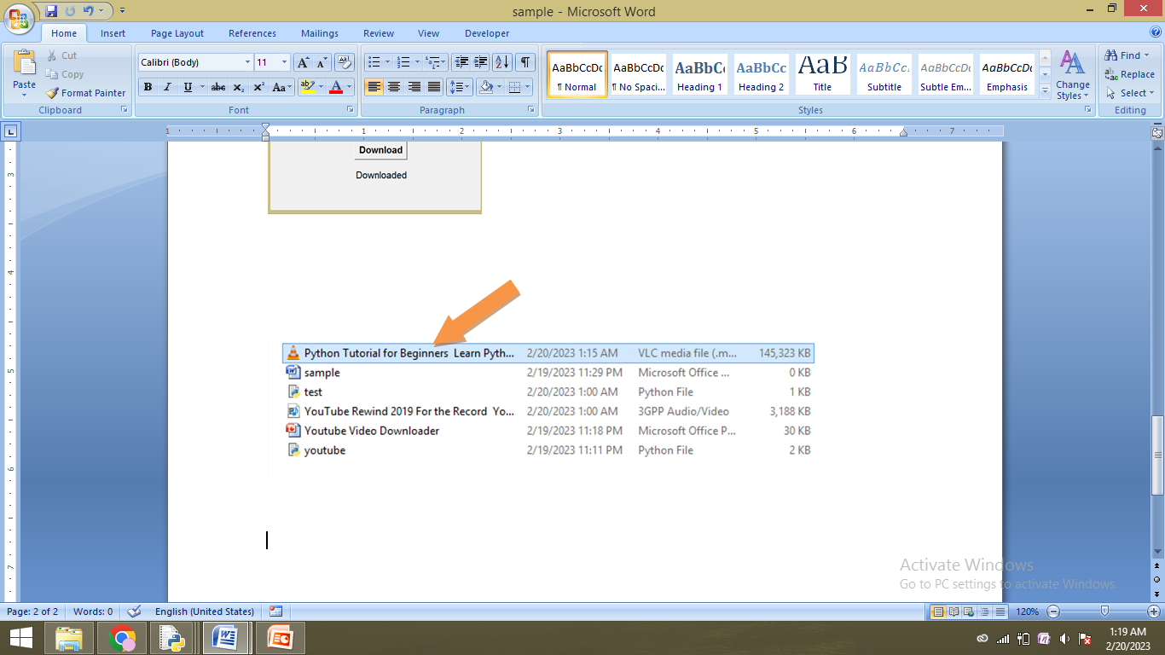

**CONCLUSION**

Python is a programming language that provides a large variety of pre-defined modules and libraries which makes it extremely easy to build a project that includes graphic user interface and many other features.

Youtube video downloader is one such project and comes in handy to download youtube videos easily without any diversions.

With this project in python, we have successfully developed the youtube video downloader project using python. We used the popular Tkinter library that used for rendering graphics. We use the pytube library to download videos from youtube.

**REFERENCES**

* <https://www.tutorialspoint.com/python/python_gui_programming.htm>
* <https://pypi.org/project/pytube/>
* <https://pytube.io/en/latest/>
* <https://www.youtube.com/>
* <https://www.youtube.com/watch?v=vLqTf2b6GZw&t=5s>